Title: Artificial Neural Network Architecture for Customer Churn Prediction
ANN Model Architecture

Overview
The Artificial Neural Networks (ANN) model designed for customer churn prediction is a deep learning model optimised for binary classification. The architecture efficiently extracts complex relationships between customer attributes and churn behaviour. It takes care to avoid overfitting and improve generalisation through the use of regularisation techniques such as dropout and batch normalisation.

Model Architecture Details
The ANN model has three dense or fully connected layers. The first hidden layer receives input from the input layer. This layer has 64 neurons. After that happens, batch normalisation is used to make learning stable, and dropout is used to prevent overfitting.
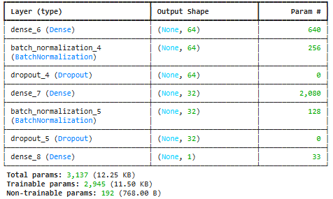
ANN Model Architecture –

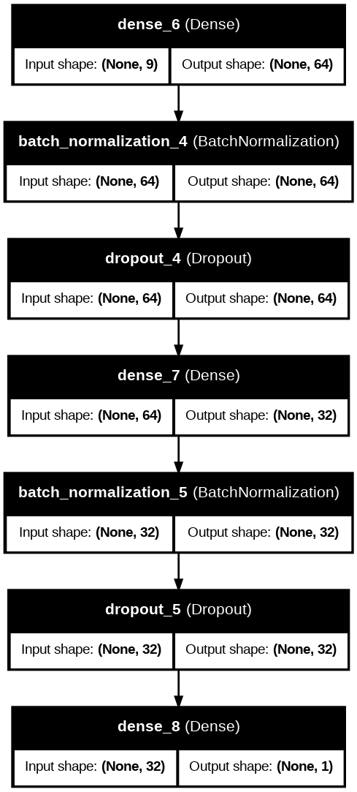
The second hidden layer employs 32 neurons and is followed by batch normalisation and dropout aimed to accelerate training. The last layer contains a single neuron with a sigmoid activation function, which outputs a probability value of churn.
This architecture contains 3,137 parameters, combining efficiency with performance. By using a dense network of connections, normalising the input, and randomly dropping out, or ignoring, a proportion of the total connections during the training phase, the model learns complex non-linear relationships, and also becomes robust and able to generalise better to unseen data during testing.

Compilation Parameters
The ANN model was compiled with the following configuration to enhance performance and ensure convergence during training.
- We selected Adam as the optimiser because of its exceptional adaptive learning rate capabilities. It is also a great optimiser that handles sparse gradients very efficiently. Because of these properties, Adam is particularly suited for problems with large datasets.
- The Loss Function we will use is Binary cross-entropy. We select this loss function because the task is to classify the output as a binary value (churn vs non-churn).
- We selected accuracy as the evaluation metric because it measures the proportion of correct churn predictions.
Using this optimiser, loss function, and metric has proven to work efficiently in predicting customer churn in the form of a classification problem.

Training Results
Training testing -
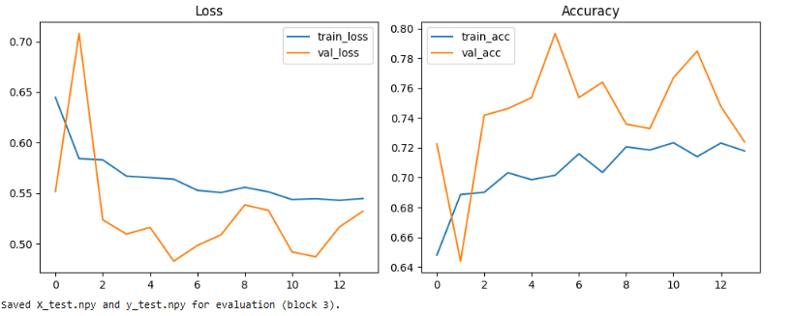
Model accuracy and classification report -
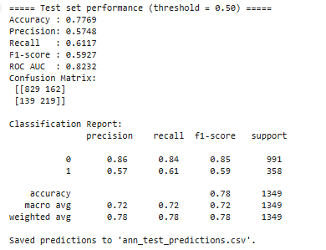
Predicted model ROC curve –
